**A Mini Project Report on**

**LIE DETECTOR**

Submitted in partial fulfillment for the award of degree

of

**BACHELOR OF ENGINEERING**

in

**ELECTRONICS ENGINEERING**

Under the Guidance of

**Prof. SANDIP ZADE**

**Submitted By**

**SINGH ABHISHEK**

**PISHARODY JISHNU**

**RATHOR ADITYA**

**DE PROBIR**

**DEPARTMENT OF ELECTRONICS ENGINEERING**



**Approved by AICTE, DTE | NAAC Accredited**

**Affiliated to University of Mumbai | ISO 9001-2015 Certified**

**ATHARVA COLLEGE OF ENGINEERING**

**Malad-Marve Road, Charkop Naka, Malad (West), Mumbai-400095**

**ACADEMIC YEAR: 2021-2022**

**ACKNOWLEDGEMENT**

We would like to express our sincere thanks to our guide Prof. Shikha Sharma, for taking time from her busy schedule to provide us with a great deal of help, support and encourage us to work diligently at every aspect of our project. Her views have always been equitable, striking a perfect balance between encouragement and constructive criticism. Her constructive tips and suggestions helped us to successfully do the project. We have benefited a lot from her immense knowledge and experience.

We express our sincere gratitude and thankfulness to Dr. S.P. Kallurkar Sir, Principal (ACE), Dr. Bhavin Shah, H.O.D., Department of Electronics Engineering (ACE) and all Staff Members of Department of Electronics Engineering (ACE) who have guided, motivated and supported us for our Mini Project.

We are thankful to the Project Coordinators, Department of Electronics Engineering (ACE), Prof. Akansha Bhargava & Dr. Bhavin Shah, for their valuable suggestions and advice.

Our project at various stages has entailed us to seek help from a variety of individuals, we would like to thank each one of them for their forbiddance and guidance.

Finally, we would like to thank our parents and our friends for constantly supporting and encouraging our efforts.

**DE PROBIR (Roll No. 07)**

**PISHARODY JISHNU (Roll No. 32)**

**ADITYA RATHOR (Roll No. 34)**

**SINGH ABHISHEK (Roll No. 41)**

**CERTIFICATE**

This is to certify that the **“SINGH ABHISHEK, PISHARODY JISHNU, ADITYA RATHOR & DE PROBIR,”** of the Department of Electronics Engineering, have submitted the Mini Project Report on “**LIE DETECTOR**”and are accepted and examined for the partial fulfillment of the Degree of Bachelor of Engineering in Electronics Engineering by the University of Mumbai.



Project Guide H.O.D. Project Coordinator

(Prof. Sandip Zade) (Dr. Bhavin Shah) (Prof. Akansha Bhargava &

Dr. Bhavin Shah)

Principal Internal Examiner External Examiner

(Dr. S. P. Kallurkar) (Prof. ) (Prof. )

Date of Examination: **02/04/2022**

**ABSTRACT**

It gives us great pleasure to introduce “**LIE DETECTOR”** as the mini project in our TE-ETRX.The goal of lie detection is the discovery of a truth that is known to one person and concealed from others. Psychophysiological lie detection, or polygraphy, is based on the theory that lying produces particular emotions, which produce corresponding measurable physiological responses. Psychophysiological lie detection dates back thousands of years.Modern polygraph measures blood pressure, breathing, and skin conductance. Alternative metrics such as voice stress analysis and functional magnetic resonance imaging are as yet unproven. The control question test uses relevant, control, and irrelevant questions. A larger response to the relevant questions is considered evidence of deception. The guilty knowledge test uses concealed information questions and irrelevant questions. Critics have questioned the theory and practice of polygraphy, primarily on the grounds that the emotion-based responses measured may not always correspond to lying. The polygraph is generally not admissible in court. Brain fingerprinting directly detects the concealed truth, such as the record of the crime stored in the brain, by measuring electrical brain responses. It has been ruled admissible in court.

**Aim:-**

To study the construction and working of Lie Detector.

**OBJECTIVES:-**

The primary purpose of the polygraph test in security screening is to identify individuals who present serious threats to national security. To put this in the language of diagnostic testing, the goal is to reduce to a minimum the number of false negative cases (serious security risks who pass the diagnostic screen).).

**TABLE OF CONTENTS**

| **SR. NO.** | **TOPIC** | **PAGE NO.** |
| --- | --- | --- |
| 1 | INTRODUCTION | 05-06 |
| 2 | LITERATURE SURVEY | 07 |
| 3 | BLOCK DIAGRAM & DESCRIPTION | 08 |
| 4 | CIRCUIT DIAGRAM & DESCRIPTION | 09 |
| 5 | ADVANTAGES & CHALLENGES | 10 |
| 6 | APPLICATIONS | 11 |
| 7 | CONCLUSION | 12 |
| 8 | FUTURE SCOPE | 13 |
| 9 | REFERENCES | 13 |

**LIST OF FIGURES**

| **Diagram** | **Page No.** |
| --- | --- |
| Figure 1: |  |
| Figure 2: |  |
| Figure 3: |  |
| Figure 4: |  |
| Figure 5: |  |
| Figure6: |  |
| Figure 6: |  |
| Figure 7: |  |
| Figure 8: |  |
| Figure 9: |  |

**INTRODUCTION**

Lie detection is an assessment of a verbal statement with the goal to reveal a possible intentional deceit. Lie detection may refer to a cognitive process of detecting deception by evaluating message content as well as non-verbal cues.It also may refer to questioning techniques used along with technology that record physiological functions to ascertain truth and falsehood in response. The latter is commonly used by law enforcement in the United States, but rarely in other countries because it is based on [pseudoscience](https://en.wikipedia.org/wiki/Pseudoscience).

There are a wide variety of technologies available for this purpose.The most common and long used measure is the [polygraph](https://en.wikipedia.org/wiki/Polygraph). A comprehensive 2003 review by the [National Academy of Sciences](https://en.wikipedia.org/wiki/National_Academy_of_Sciences) of existing research concluded that there was "little basis for the expectation that a polygraph test could have extremely high accuracy. There is no evidence to substantiate that [non-verbal](https://en.wikipedia.org/wiki/Nonverbal_communication) lie detection, such as by looking at body language, is an effective way to detect lies, even if it is widely used by law enforcement.

Lie detection commonly involves the [polygraph](https://en.wikipedia.org/wiki/Polygraph), and is used to test both styles of deception. It detects [autonomic](https://en.wikipedia.org/wiki/Autonomic_nervous_system) reactions, such as micro-expressions, breathing rate, skin conductivity, and [heart rate](https://en.wikipedia.org/wiki/Heart_rate). Microexpressions are the brief and incomplete nonverbal changes in expression while the rest show an activation of the nervous system. These changes in body functions are not easily controlled by the conscious mind. They also may consider [respiration rate](https://en.wikipedia.org/wiki/Respiration_rate), [blood pressure](https://en.wikipedia.org/wiki/Blood_pressure), capillary dilation, and muscular movement. While taking a polygraph test the subject wears a blood pressure device to measure blood pressure fluctuations. Respiration is measured by wearing pneumographs around the chest, and finally electrodes are placed on the subject's fingers to measure skin conductivity. To determine truth it is assumed the subject will show more signs of fear when answering the control questions, known to the examiner, compared with the relevant questions, where the answers are not known. Polygraphs focus more on the exams predictive value of guilt by comparing the responses of the participant to control questions, irrelevant questions, and relevant questions to gauge arousal, which is then interpreted as a display of fear and deception is assumed. If a person is showing a deception there will be changes in the autonomic arousal responses to the relevant questions. Results are considered inconclusive if there is no fluctuation in any of the questions. These measures are supposed to indicate a short-term [stress response](https://en.wikipedia.org/wiki/Stress_response) which can be from lying or significance to the subject. The problem becomes that they are also associated with mental effort and [emotional state](https://en.wikipedia.org/wiki/Emotional_state), so they can be influenced by fear, anger, and surprise for example.

The guilty knowledge test uses concealed information questions and irrelevant questions. Critics have questioned the theory and practice of polygraphy, primarily on the grounds that the emotion-based responses measured may not always correspond to lying. The polygraph is generally not admissible in court. Brain fingerprinting directly detects the concealed truth, such as the record of the crime stored in the brain, by measuring electrical brain responses. It has been ruled admissible in court. The theory behind the polygraph technique holds that a conscious mental effort to deceive made by a normal, healthy person will cause certain physiological changes detectable by the polygraph instrument.

**LITERATURE SURVEY**

Professor Yael Hanein, an electrical engineer and nanotechnologist at Tel Aviv University, has worked with colleague Professor Dino Levy, a psychobiologist, to create a lie detector system that uses a test subject’s microexpressions to determine the truthfulness of a statement. Using electrodes attached to the subject’s face, the test looks for involuntary eyebrow and lip movements—two signs that Hanein and her colleague say occur with a majority of liars.

**BLOCK DIAGRAM**

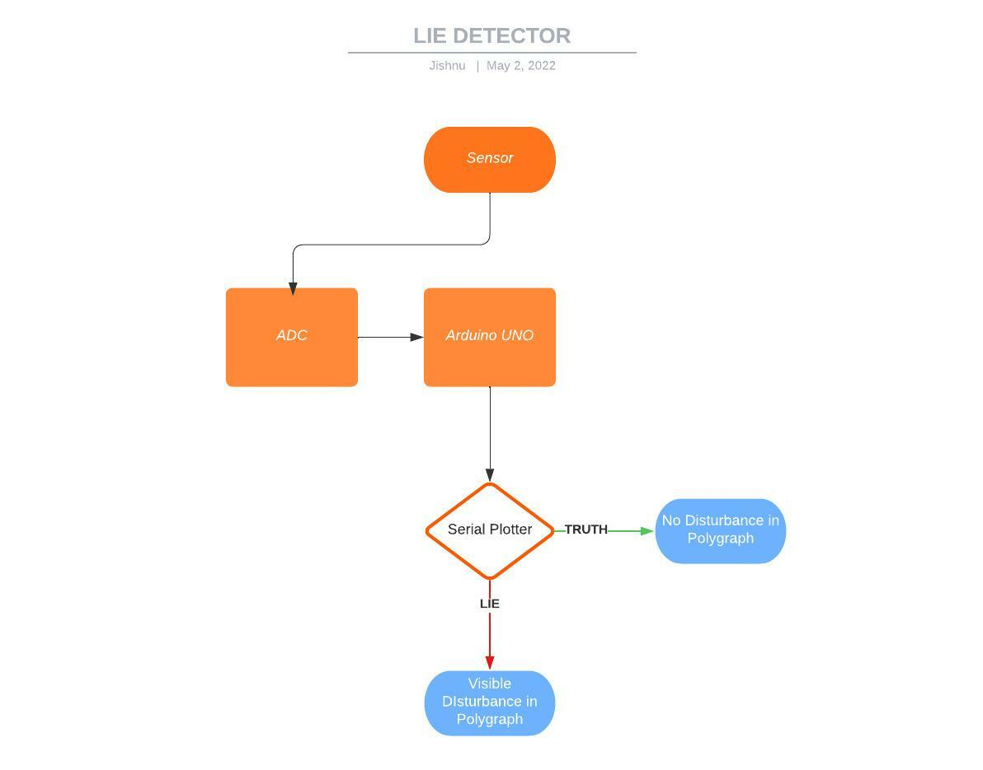

**CIRCUIT DIAGRAM & DESCRIPTION:-**

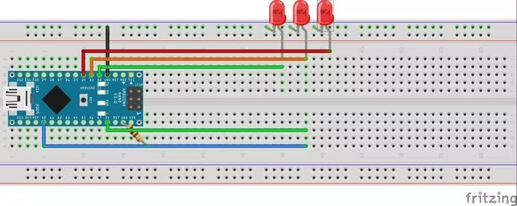

Circuit diagram of Lie Detector.

**STEP 1:-**

HOW IT WORKS Our skin is amazing! It provides a medium for us to experience the sense of touch, it keeps infections out and keeps innards in but you didn't know that our skin changes conductivity depending on many different things one being our mood! It called Electro dermal activity (EDA).The basics are that our skin changes its conductivity depending on how we feel. We start by connect our Arduino to the subject and then connect the Arduino to a computer with the software. We have to start by asking the subject some easy questions we know they will answer truthfully like "what is your name" and "where do you live" to get a baseline and from there we can start asking questions that they may lie about, if they do they would probably feel nervous and then we can read the change in the baseline that be established earlier if they lie.

**STEP 2:-**

COMPONENTS WE HAVE USED We are going to need a microcontroller to control the two LEDs and send the computer the data. In order for the computer receive the data from the microcontroller to have a serial communication chip (USB communication chip).Hence we required

1. Arduino UNO

2. LEDs

3. Resistors(10K)

4. Sensors

**STEP 3:-** CONNECTIONS Connect the resistors with their required position and connect with Arduino uno . Finally, we need to keep the sensor wires on our fingers.

**STEP 4:-** SOFTWARE INSTALLATION and CODE GENERATION The new update brings a new way to see the data being received from the Arduino,it can now be displayed in a real time graph which will help us identify when the data changes its pattern(when someone lies). The code for the microcontroller downloads the attached file, we have to open it and upload it on board.

**ADVANTAGES & CHALLENGES**

Advantages of Lie Detector:

1. For the criminals it is very easy to fool the law and the security forces by telling lies and easily dodging them, and so in order to confess the truth, these agencies use lie detector machines.
2. A polygraph test can help in numerous situations to help uncover the truth. They are incredibly useful and accurate, with an average success rate of 90% or higher. There is no pain associated with the test and they are both affordable and accessible.
3. Polygraph tests have great significance as they have several useful practical applications. They are valuable instruments used to detect truthfulness and deceitful behavior in several fields.
4. Legacy system with long history of use in law enforcement and military applications; its use has been challenged in court, but in some cases, polygraph testimony has been allowed.
5. Use has been challenged in court, but in some cases, polygraph testimony has been allowed.
6. The polygraph process is well-known due to exposure in the media/popular culture.

Disadvantages of Lie Detector :

1. If the person lies but doesn’t have the stress symptoms of telling that lie, they will pass the test. Similarly, innocent people may fail the test due to being anxious about taking it to begin with and therefore emitting elevated heart, respiratory, and blood pressure rates that can be detected.
2. The polygraph is still vulnerable to both physical and psychological countermeasures and it also suffers from a significant error rate based upon inconclusive, false positives, or false negatives results. Manipulation sometimes plays a major role in escaping these cases.
3. Although polygraph tests have certain useful practical applications, there are several challenges. Accuracy and ethics issues are more frequently raised challenges to polygraph tests.
4. Subject to countermeasures, false positives, false negatives, and inconclusive results.
5. Accuracy rates can vary from 50 percent to 87.5 percent.
6. The examination is lengthy and requires a subject to remain still while hooked up to numerous sensors.

**APPLICATIONS**

1. The primary purpose of the polygraph test in security screening is to identify individuals who present serious threats to national security. To put this in the language of diagnostic testing, the goal is to reduce to a minimum the number of false negative cases (serious security risks who pass the diagnostic screen).
2. The polygraph is still used as a tool in the investigation of criminal acts and sometimes employed in the screening of employees for government organizations.
3. The purpose of pre-employment screening is to determine whether or not an applicant is being truthful regarding his/her application form. The questions are usually focused on employment history, credits, driving, falsification of information and any criminal record.
4. Clinical testing :

* Disclosure testing
* Maintenance testing
* Specific testing

**CONCLUSION:**

Thus in our project “LIE DETECTOR” we have been able to establish three parameters that are sweat resistance detection, temperature measurement and heart rate measurement .Therefore with this three parameters we can detect whether a person is telling the lie or not. But as this is a low cost project for this reason there are many kind of noises for which we are getting garbage values and hence the actual reading is not showing sometimes. We also had think of two other parameters to include in our project i.e. ECG and EEG but due to lack of time and budget problems we were not able to come up with these two parameters. Otherwise we are able to accomplish our aim with the former three parameters which we have mentioned earlier in our work plan.

**FUTURE SCOPE:**

* We can add a heart rate sensor, pulse monitoring system as well as an electrocardiogram plotter so that the output i.e polygraph could be plotted more accurately.

**REFERENCE SITES:-**

1. https://create.arduino.cc/projecthub/BuildItDR/arduino
2. https://people.howstuffworks.com/lie-detector.htm
3. https://en.wikipedia.org/wiki/Polygraph
4. https://www.britannica.com/story/do-lie-detectors-actually
5. https://spectrum.ieee.org/a-brief-history-of-the-lie-detector
6. https://science.howstuffworks.com/question123.html

**PROJECT PROGRESS REPORT**

| **Date** | **Activity** | **Outcome** | **Comment on Outcome** | **Resources Utilized** | **Next Meeting Date** | **Target** | **Remarks of Project Guide** |
| --- | --- | --- | --- | --- | --- | --- | --- |
| 11/04/2022 | Research started | Topic decided | - | Google | 14/04/2022 |  |  |
| 14/04/2022 | PPT and REPORT | Completed | - | Powerpoint and Word | 16/04/2022 |  |  |
| 16/04/2022 | Simulation | Completed | - | Using  Components |  |  |  |
|  |  |  |  |  |  |  |  |
|  |  |  |  |  |  |  |  |
|  |  |  |  |  |  |  |  |
|  |  |  |  |  |  |  |  |
|  |  |  |  |  |  |  |  |